**ASSIGNMENT 13.1**

**PROBLEM STATEMENT :**

Perform below operations in Hbase shell ● Create the table customer with two column families - Personal details and order details as column families. ● Create a unique number as row key (ssn/Adhar no.,etc) Insert at least 10 records to each column Insert following values for personal details column family - Name, age, city, state. ● Insert following values for order details column family ● Order no, order quantity, and order amount ● Use put command to insert the values for each record. ● Use get command, to retrieve all the records of single customer.

**PROCESS :**

**● Create the table customer with two column families - Personal details and order**

**details as column families.**



**● Create a unique number as row key (ssn/Adhar no.,etc) Insert at least 10**

**records to each column Insert following values for personal details column family**

**- Name, age, city, state.**

**● Insert following values for order details column family**

**● Order no, order quantity, and order amount**

**● Use put command to insert the values for each record.**

**Example insertion for one row:**

The process of the insertion of the one row is being shown in the below screenshot respectively.

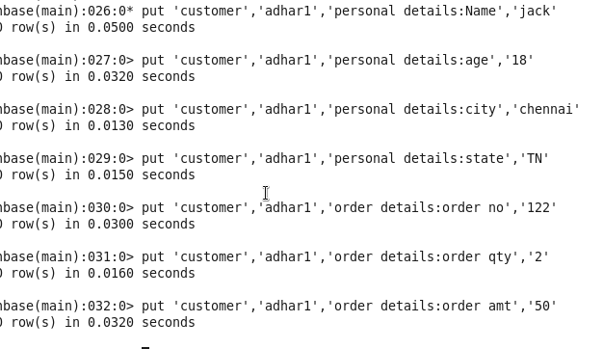

**● Use get command, to retrieve all the records of single customer.**

